**ИП-194_Пиянзов М.**

**Практическая работа 8**

**Тема. SQLite. Методы update и delete с указанием условия**

**Цель:** - используем методы update и delete с указанием условия

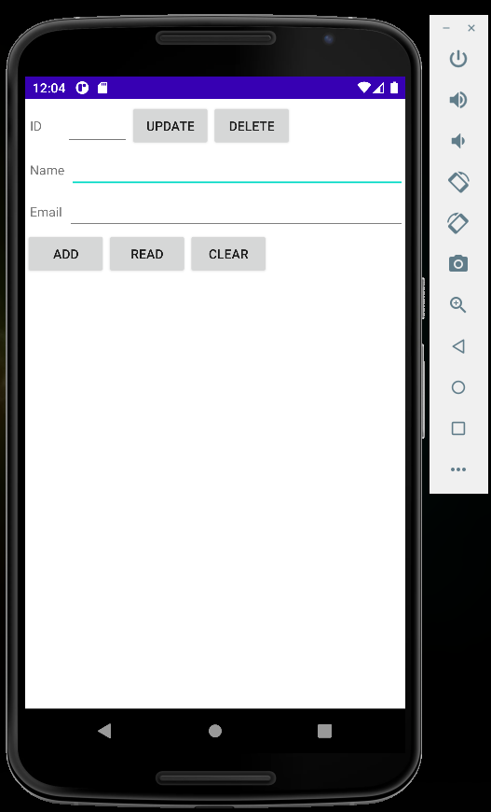

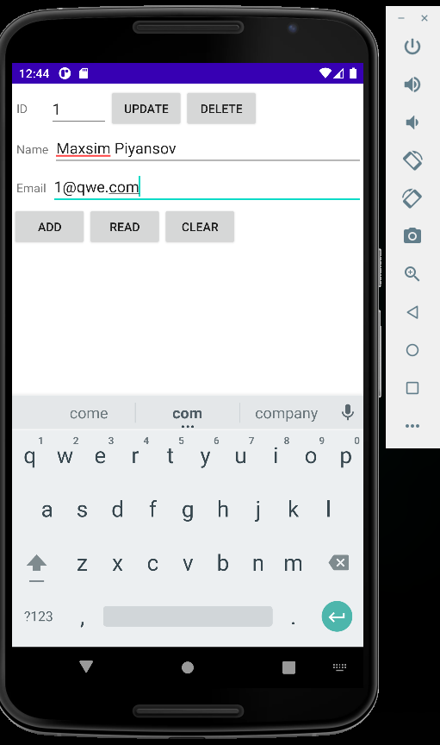

D/myLogs: --- Insert in mytable: ---

D/myLogs: row inserted, ID = 18

D/myLogs: --- Update mytable: ---

D/myLogs: updated rows count = 0

D/myLogs: --- Rows in mytable: ---

D/myLogs: ID = 9, name = maxim, email = 32t345342@gmail.ru

ID = 10, name = maxim, email = 32t345342@gmail.ru

ID = 11, name = 32, email = 12121

ID = 12, name = 32, email = 12121

ID = 13, name = 32, email = 12121

ID = 14, name = 32, email = 12121

ID = 15, name = 32, email = 12121

ID = 16, name = 32, email = 12121

ID = 17, name = Ivan Petrov, email = ipetrov@abc.com

ID = 18, name = xc, email = 6554

D/myLogs: --- Rows in mytable: ---

ID = 9, name = maxim, email = 32t345342@gmail.ru

ID = 10, name = maxim, email = 32t345342@gmail.ru

ID = 11, name = 32, email = 12121

ID = 12, name = 32, email = 12121

ID = 13, name = 32, email = 12121

ID = 14, name = 32, email = 12121

ID = 15, name = 32, email = 12121

D/myLogs: ID = 16, name = 32, email = 12121

ID = 17, name = Ivan Petrov, email = ipetrov@abc.com

ID = 18, name = xc, email = 6554

D/myLogs: --- Rows in mytable: ---

D/myLogs: ID = 9, name = maxim, email = 32t345342@gmail.ru

ID = 10, name = maxim, email = 32t345342@gmail.ru

ID = 11, name = 32, email = 12121

ID = 12, name = 32, email = 12121

ID = 13, name = 32, email = 12121

ID = 14, name = 32, email = 12121

ID = 15, name = 32, email = 12121

ID = 16, name = 32, email = 12121

ID = 17, name = Ivan Petrov, email = ipetrov@abc.com

ID = 18, name = xc, email = 6554

D/myLogs: --- Rows in mytable: ---

D/myLogs: ID = 9, name = maxim, email = 32t345342@gmail.ru

ID = 10, name = maxim, email = 32t345342@gmail.ru

ID = 11, name = 32, email = 12121

ID = 12, name = 32, email = 12121

ID = 13, name = 32, email = 12121

ID = 14, name = 32, email = 12121

ID = 15, name = 32, email = 12121

ID = 16, name = 32, email = 12121

ID = 17, name = Ivan Petrov, email = ipetrov@abc.com

ID = 18, name = xc, email = 6554

D/myLogs: --- Clear mytable: ---

D/myLogs: deleted rows count = 10

D/myLogs: --- Delete from mytable: ---

D/myLogs: deleted rows count = 0

D/myLogs: --- Delete from mytable: ---

deleted rows count = 0

D/myLogs: --- Rows in mytable: ---

0 rows

D/myLogs: --- Delete from mytable: ---

deleted rows count = 0

D/myLogs: --- Rows in mytable: ---

0 rows

D/myLogs: --- Delete from mytable: ---

D/myLogs: deleted rows count = 0

D/myLogs: --- Rows in mytable: ---

D/myLogs: 0 rows

D/myLogs: --- Insert in mytable: ---

D/myLogs: row inserted, ID = 19

D/myLogs: --- Insert in mytable: ---

D/myLogs: row inserted, ID = 20

D/myLogs: --- Update mytable: ---

D/myLogs: updated rows count = 0

D/myLogs: --- Delete from mytable: ---

deleted rows count = 0

D/myLogs: --- Rows in mytable: ---

D/myLogs: ID = 19, name = Maxsim Piyansov, email = 1@qwe.com

ID = 20, name = Maxsim Piyansov, email = [1@qwe.com](mailto:1@qwe.com)

**Вывод:** Научился использовать методы update и delete с указанием условия